**Registration System 1.0**

**Administrator User Documentation**

**2016**

**NOTES:** Please note the word “course” and “class” are treated synonymously for students and professors. This is because the aforementioned tend to think predominantly in terms of “adding a course,” “dropping a course,” “teaching a course,” and so on, when technically these actions are class-based. Administrators must make a distinction, however. Technically an administrator is creating a class and associating the class with a course. This distinction is made apparent within how the GUI labels its terms.

**Navigation**

As an administrator you manage various aspects of the system. At the top of the app you have the following functionalities:



*Course listing* shows you all the courses currently offered*.*

*New Class* Allows you to add a new course/class association which will appear under “Course Listing”.

*New User* will create a new student or professor account

*Search users* will allow you to search users to view/modify their account

*Pending Approval* is a list of user accounts pending approval.

*Change Password* allows you to change your password

*Logout* will log you out of the application.

**Adding a Class**

Creating a course listing from the perspective of a student or professor is making a class and associating that class with a course from the perspective of an administrator. Therefore you must first select the course:

**1. Select a Course**

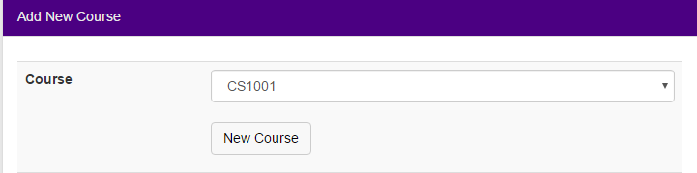

In the example above “CS1001” has been selected from the drop down menu. If the course you wish to make is not listed under the drop down menu then the course is unknown to the system. Select “New Course” to add the course to the application. You will be prompted for the course information as follows:

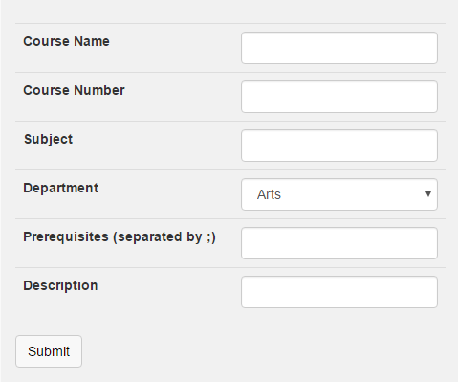

Fill the information and hit “submit”. The course will now appear under the drop down menu for you to select.

The next piece of information asked for is the term. If the term does not exist under the drop down menu then you will need to create a new term. To do so select the “New Term button”

**2. Select a Term**



You will be prompted with a dialog asking for term information. Enter and submit this information. The new term will then appear under the drop down menu.

**3. Fill out the building location (optional)**

**4. Select the time.** The following diagram shows the dialog for selection times:

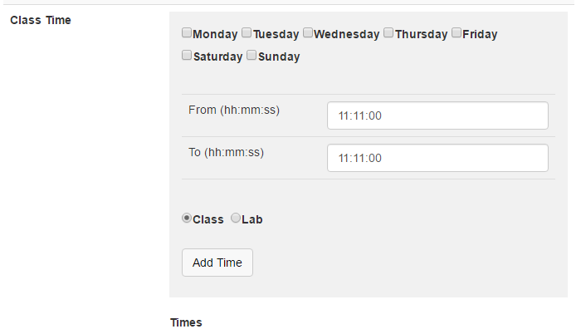

Select which days the classes will be held, and the time for the classes. If classes start at different times on different day then you will need to add times on a day-by-day basis. After courses have been added you will be shown the time listings:

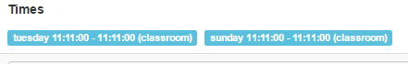

Click on the time listing to remove it (for example if you made a mistake).

**4. Fill out the rest of the information.** The remaining information to be entered is self-explanatory.

After the information is filled out submit the form.

**Modifying a Course Listing**

Modifying a course listing means you are modifying the class information associated with the course (e.g., when the course starts and ends). You may modify a course by navigating to the “Modify Class” section of the application. The process in modifying the course is the same as creating a new course so please see the above section. Alternatively you may modify a class under the “All Classes” section of the application (see “All Classes section”).

**Adding Users**

You may add new users manually. Users may be professors or students. After a user is added you will be given their initial login information. Forward this to the user. Add a user by navigating to the “New User” section of the application.

Most of the requested information for the user is self-explanatory. However, a note should be made on the account status, as shown in this diagram:

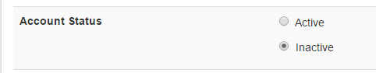

A user account may have two states: active or inactive. Inactivating a user’s account will prevent him or her from accessing account features.

**Modify Users**

You may modify a user’s account by navigating to the “Modify User” page. You will be shown a search feature for looking up users.

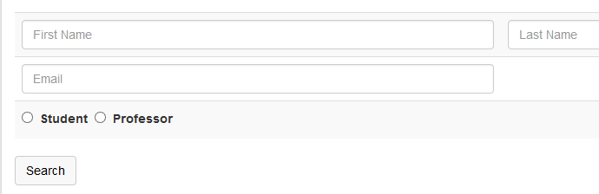

After you enter a user’s first, last name and or relevant information then submit the forum you will be shown a list of users best matching your request:

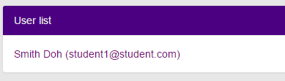

Click on the user you wish to modify or view.

**Accounts Pending Approval**

Accounts that professors or users make themselves need to be approved. You may view the list of accounts awaiting approval in the “Pending Approval” section of the website. An example list is the following:

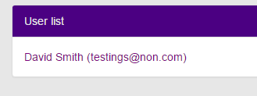

Click on an account listing to view the account details and decide if you will approve the account. To approve the account change the account status’ radio button from “inactive” to “active”:

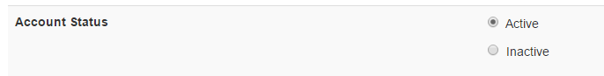

And submit the form by clicking the “submit” button at the bottom of the application.

**Viewing Courses**

“All Courses” allow you to view all courses currently offered. You may search for courses by course id, category, or both. The below diagram shows the search feature:

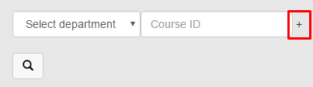

Notice the marked “+” sign in red. Clicking this icon will add an additional search filter.

The below diagram shows an example of a course listing:

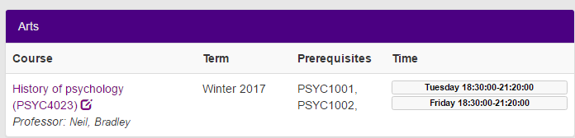

Clicking on the “History of Psychology (PSYC4023)” will show you more information about the course:

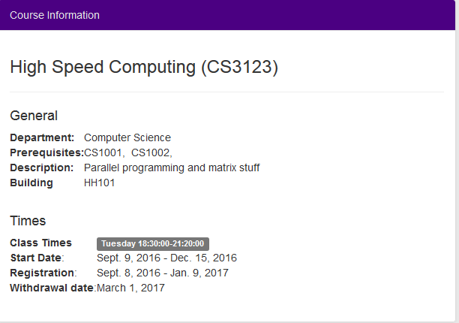

You may modify the course by selecting the edit icon next to the course name